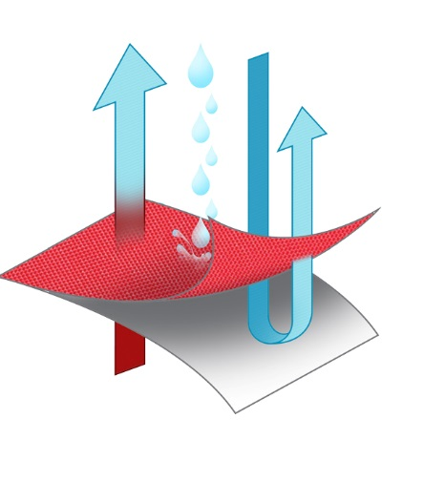
Eurohunter Synthetic Rug Technology
Moisture Vapor
Escapes
Rain and Wind Stay Out

Outer
Material
Aquabreath Technology
Aquabreathe waterproof breathable technology.
Allows moisture vapor to escape whilst repelling rain and wind.
The higher the series number the greater the waterproof ability
and breathability.
Aquabreathe Membrane
The following features are available across the range with some like the Ultra and Eskimo combing all of the below features.
- Wither V to relieve pressure
- Rump Darts for an improved snug fit
- Tripled – D Front Chest Closure system for greater adjustability.
- Secure Fit Chest flap for comfort and warmth.
- T-Locking Stainless Steel Surcingle Fittings
- Reflective Piping for greater visibility

